***BEEE LAB EVALUATION PHASE 1***

**Circuit Diagram:**

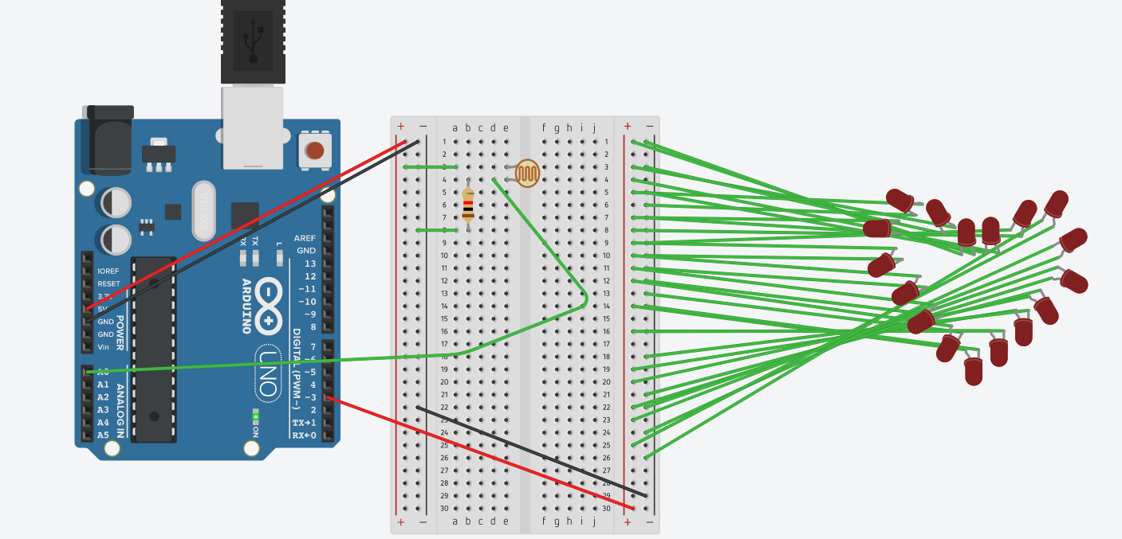

**Theory**

Concept Used: Design a system for a red coloured magical heart pendant that blinks 60 times a minute and stops blinking and turns blue during night.

Learning & Observations: when the LDR detects low intensity of light it allows the current to pass through the LEDs .

Problems & Troubleshooting: LED was found to be fused and Arduino can be faulty and it can be resolved by changing the elements

Precautions: Resistor should be connected to LED so that the flow of current remains low and preserves LED from damaging.

Learning Outcomes: LED is a diode having two ends P-type and N-type and glows with a very less amount of current. Arduino IDE is used to program the microprocessor in certain way given.